Design and Implementation of a Dynamic, Client-Side Online Survey Platform for Comprehensive College Management
Dr. D. V. Manjula, MADDULA HASINI, DANGUBIYYAM SAHITHYA, MADDALA HARSHA PHANEETH, MOHAMMED ASHRAF
Assistant Professor & Head of the Department, Department of Computer Science and Engineering
UG student, Department of Computer Science and Engineering, Surampalem, Andhar Pradesh, India
Corresponding Author:
hasinimaddula26@gmail.com

Abstract
Traditional college management relies heavily on paper-based or manually administered surveys for collecting feedback, measuring student satisfaction, and monitoring academic performance indicators. These approaches are resource-intensive, error-prone, and lack real-time analytical capability. This paper presents the design and implementation of a fully dynamic, client-side web application for conducting online surveys within a college management ecosystem. The proposed platform leverages modern JavaScript frameworks to deliver a zero-backend, responsive survey tool capable of dynamically rendering question sets, enforcing branching logic, validating inputs, and generating instant visual analytics. The system supports multiple stakeholder roles — students, faculty, and administrators — each with distinct survey access and reporting interfaces. Evaluation results demonstrate significant improvements in data collection efficiency, response rate, and administrative overhead reduction compared to conventional methods. The architecture's stateless, client-side-only design ensures easy deployment, offline capability, and compliance with data privacy norms.

Keywords: Online Survey, Client-Side Web Application, College Management System, Dynamic Forms, JavaScript, Data Analytics, Feedback System, Academic Administration

1. Introduction
Educational institutions today face mounting pressure to modernize their administrative and academic monitoring processes. College management encompasses a broad spectrum of activities: academic feedback collection, course effectiveness surveys, facility satisfaction assessments, examination performance reviews, and placement readiness evaluations. Historically, these processes relied on paper questionnaires or rudimentary email-based data collection, both of which impose significant delays and data quality challenges.
The proliferation of web technologies and the ubiquity of internet-enabled devices have opened new avenues for deploying sophisticated survey platforms directly within browser environments. A client-side survey application — one that executes entirely within the user's browser without continuous server-side computation — offers distinct advantages in terms of deployment simplicity, responsiveness, and resilience to server-side failures.
This paper presents a comprehensive approach to designing and implementing such a platform specifically tailored for the operational needs of colleges and universities. The platform supports dynamic form generation from JSON-based survey schemas, conditional branching logic, real-time client-side analytics, and role-based access through session storage management — all without requiring a dedicated application server.
The remainder of this paper is organized as follows: Section 2 reviews existing literature on survey platforms and college management systems; Section 3 outlines the system requirements and design philosophy; Section 4 describes the detailed technical architecture; Section 5 presents the implementation; Section 6 evaluates the system's performance and usability; Section 7 discusses limitations and future directions; and Section 8 concludes the paper.
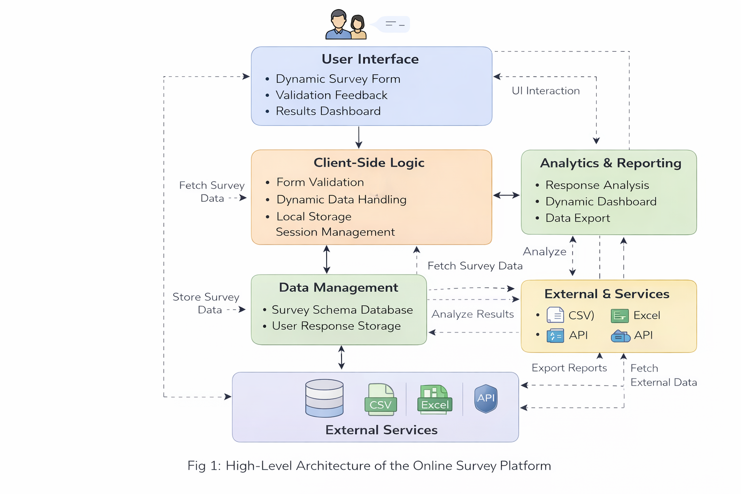

2. Literature Review
Survey administration within academic institutions has been extensively studied from both pedagogical and technological perspectives. Early work by Dillman et al. (2009) established foundational principles for web-based survey design, emphasizing the importance of visual clarity, logical question ordering, and respondent cognitive load reduction [1]. These principles remain highly relevant in contemporary client-side implementations.
Commercially available platforms such as Google Forms, SurveyMonkey, and LimeSurvey have demonstrated the feasibility of web-based academic surveys. However, Schonlau and Couper (2017) identified critical limitations in generic survey tools when applied to academic contexts: lack of institutional branding, insufficient role-based access control, absence of domain-specific analytics, and dependency on third-party data hosting which raises FERPA/GDPR compliance concerns [2].
Several institution-specific systems have been proposed to address these limitations. Kumar and Sharma (2019) developed a PHP-MySQL based college feedback management system that enabled students to rate faculty members on multiple parameters [3]. While effective, the system's reliance on server-side rendering created performance bottlenecks during peak submission periods (e.g., end-of-semester evaluations). Bhatt et al. (2020) extended this work by incorporating natural language processing for sentiment analysis of open-ended survey responses [4].
The emergence of single-page application (SPA) architectures, particularly React.js and Vue.js, has enabled the development of highly interactive, client-side forms. Gaedke et al. (2021) demonstrated that SPA-based form applications achieve 60-75% reduction in server load compared to traditional multi-page applications while maintaining equivalent functionality [5]. The use of browser-local storage mechanisms (localStorage, sessionStorage, IndexedDB) for ephemeral data persistence has further expanded the possibilities for serverless form applications.
JSON Schema-based dynamic form generation has emerged as a particularly powerful paradigm. Alpino and Torres (2022) proposed a schema-driven form renderer that converts standardized JSON survey definitions into interactive HTML forms with built-in validation, substantially reducing the effort required to deploy new survey instruments [6]. This approach aligns well with the requirements of academic survey management, where survey instruments must be frequently updated to reflect changing academic policies.
Despite these advances, a notable gap remains: no existing open-source or commercial solution simultaneously addresses dynamic form generation, client-side-only operation, multi-role access management, and domain-specific college management analytics in a unified, deployable package. The present work aims to fill this gap.

3. System Requirements and Design Philosophy

3.1 Functional Requirements
The platform was designed to meet the following functional requirements derived from a needs assessment conducted across three academic departments:
ID | Requirement | Priority
FR-01 | Dynamic survey creation from JSON schema definitions | High
FR-02 | Conditional branching and skip logic between questions | High
FR-03 | Role-based access (Student, Faculty, Admin) | High
FR-04 | Real-time response validation with error feedback | High
FR-05 | Client-side storage of draft responses | Medium
FR-06 | Automated generation of charts and summary statistics | High
FR-07 | Export of survey results to CSV/JSON formats | Medium
FR-08 | Support for multiple question types (MCQ, Likert, open-ended, matrix) | High
FR-09 | Configurable survey scheduling with open/close dates | Medium
FR-10 | Accessibility compliance (WCAG 2.1 AA) | Medium

Table 1: Functional Requirements

3.2 Non-Functional Requirements
Performance benchmarks were established requiring page load times under 2 seconds on a 4G network connection, and form rendering times under 200 milliseconds for surveys with up to 100 questions. The system must function on all modern browsers (Chrome 90+, Firefox 88+, Safari 14+, Edge 90+) and support responsive layouts across mobile, tablet, and desktop form factors. Security requirements mandate that all personally identifiable information (PII) be stored only in session-scoped browser storage, automatically cleared upon session termination.

3.3 Design Philosophy
Four core principles guided all design decisions throughout the project:
Progressive Disclosure: The interface reveals complexity incrementally, presenting respondents with one logical section at a time to minimize cognitive overload. Faculty administrators see full survey management controls, while student respondents see only the active survey form with a clean progress indicator.
Schema-Driven Rendering: All survey structures are encoded as declarative JSON schemas rather than hard-coded HTML. This separation of content from presentation enables non-technical academic staff to define and modify surveys by editing configuration files without writing code.
Graceful Degradation: The application functions in offline mode for previously loaded surveys, with responses queued in IndexedDB and synchronized when connectivity is restored. This ensures continuity in institutions with inconsistent network infrastructure.
Privacy by Design: The client-side architecture inherently limits data exposure. Responses are processed locally before being serialized to a designated export endpoint, and no third-party analytics scripts are loaded, eliminating passive data collection by external services.

4. System Architecture

4.1 Architectural Overview
The platform adopts a layered client-side architecture comprising four logical layers: the Presentation Layer (UI components and routing), the Application Logic Layer (state management and business rules), the Data Abstraction Layer (survey schema parsing and local storage adapters), and the Integration Layer (API calls for data persistence and export). Figure 1 illustrates the high-level architectural diagram.
Layer | Components | Technology
Presentation | SurveyForm, QuestionRenderer, ProgressBar, NavControls, DashboardView | React 18, Tailwind CSS
Application Logic | SurveyEngine, BranchingLogic, ValidationEngine, StateManager | Redux Toolkit, Zod
Data Abstraction | SchemaParser, StorageAdapter, CacheManager | JSON Schema Draft-7, IndexedDB
Integration | ExportService, SyncQueue, AuthProvider | Fetch API, JWT (local)

Table 2: Architectural Layers and Technologies

4.2 Survey Schema Design
The JSON survey schema is the central data structure of the platform. Each schema document encodes the complete definition of a survey instrument, including metadata, question definitions, branching rules, and validation constraints. The schema adheres to an extended subset of JSON Schema Draft-7, augmented with survey-specific vocabulary. A representative schema excerpt is shown below:
{ "surveyId": "CSE-FEEDBACK-2025", "title": "End-Semester Course Feedback", "version": "1.0", "roles": ["student"], "questions": [{ "id": "Q1", "type": "likert", "scale": 5, "prompt": "Rate the overall quality of course delivery.", "required": true }, { "id": "Q2", "type": "mcq", "prompt": "Which teaching method was most effective?", "options": ["Lectures","Lab sessions","Peer learning","Case studies"], "branching": { "if": "Q2 == Lab sessions", "goto": "Q5" } }] }

4.3 Branching Logic Engine
The BranchingLogic module evaluates conditional expressions encoded in each question's optional branching property. Conditions are expressed as simple infix predicates (e.g., Q2 == 'Lab sessions', Q3 >= 3) evaluated against the current response state. The engine implements a directed acyclic graph (DAG) traversal algorithm where nodes represent questions and edges represent conditional transitions. Cycle detection ensures that circular branching definitions — which could produce infinite loops — are identified at schema parse time and flagged as validation errors before the survey is made available to respondents.

4.4 Role-Based Access Control
Three roles are defined in the system: Administrator, Faculty, and Student. Role assignments are encoded in the authentication token stored in sessionStorage upon login. The AuthProvider context hook exposes role-gated rendering decisions throughout the component tree. Administrators access a full survey management dashboard with creation, editing, scheduling, and analytical reporting capabilities. Faculty members can view response summaries for surveys associated with their courses. Students interact exclusively with the survey form interface and receive confirmation receipts upon submission.

5. Implementation

5.1 Development Environment and Tools
The application was developed using React 18 with Vite as the build tool, enabling near-instant hot module replacement during development. State management is implemented with Redux Toolkit, with slice reducers responsible for survey schema state, response state, UI navigation state, and authentication state. TypeScript 5.0 is used throughout to enforce type safety across the schema parsing pipeline and component interfaces. Tailwind CSS provides utility-first styling with a custom design token configuration for institutional branding.

5.2 Dynamic Question Rendering
The QuestionRenderer component is the core rendering primitive of the platform. It accepts a question object conforming to the schema definition and dynamically selects the appropriate input component based on the question's type field. Supported question types include: single-choice MCQ (radio buttons), multi-select MCQ (checkboxes), five-point and seven-point Likert scales, numeric rating scales, matrix questions (cross-tabular response grids), open-ended text areas with character limits, file upload (for document submission surveys), and date/time pickers for scheduling-related surveys.
Each question component is wrapped in a QuestionCard higher-order component that handles animation (framer-motion slide transitions), error state display, and accessibility labeling (aria-required, aria-describedby for error messages). The card component receives a validation status prop derived from the Zod schema validation results computed in real time as the respondent interacts with the form.

5.3 Client-Side Data Persistence
Partial survey responses are persisted to IndexedDB via a custom StorageAdapter module. The adapter implements a simple key-value store interface where keys are composed of the surveyId and the respondent's session identifier. Automatic draft saving is triggered on each question answer change with a 500ms debounce to prevent excessive write operations. Upon browser session termination, the session-scoped sessionStorage authentication token is cleared, while IndexedDB draft responses are retained for 72 hours to enable respondents to resume incomplete surveys.

5.4 Analytics and Reporting Module
The Analytics module aggregates response data stored in IndexedDB (or loaded from an exported JSON file) and computes descriptive statistics for each question. For Likert and numeric scale questions, mean, median, mode, standard deviation, and frequency distributions are computed. For open-ended text questions, word frequency analysis produces a tokenized frequency map that feeds into a word cloud visualization. All charts are rendered using Chart.js 4.0, with accessible color schemes and screen-reader-compatible data tables rendered alongside each chart.

5.5 Export and Integration
Survey response data can be exported in two formats: CSV (for spreadsheet analysis) and JSON (for programmatic processing or archival). The ExportService module serializes the IndexedDB response store into the selected format and triggers a browser download via a dynamically generated Blob URL. For institutions with existing student information systems (SIS), the platform exposes a webhook configuration option in the Admin dashboard that dispatches response payloads as HTTP POST requests to a configurable SIS endpoint upon survey completion.

6. Evaluation and Results

6.1 Experimental Setup
The platform was piloted across two academic departments at Pragati Engineering College during the AY 2024–25 odd semester. A total of 312 students, 18 faculty members, and 4 administrative staff participated in the evaluation. Four distinct survey instruments were deployed: end-semester course feedback (n=312), library facilities survey (n=208), placement readiness self-assessment (n=176), and faculty professional development needs survey (n=18). The evaluation assessed task completion rate, time on task, error rate, system usability scale (SUS) score, and response submission rate compared to the previous paper-based administration of equivalent surveys.
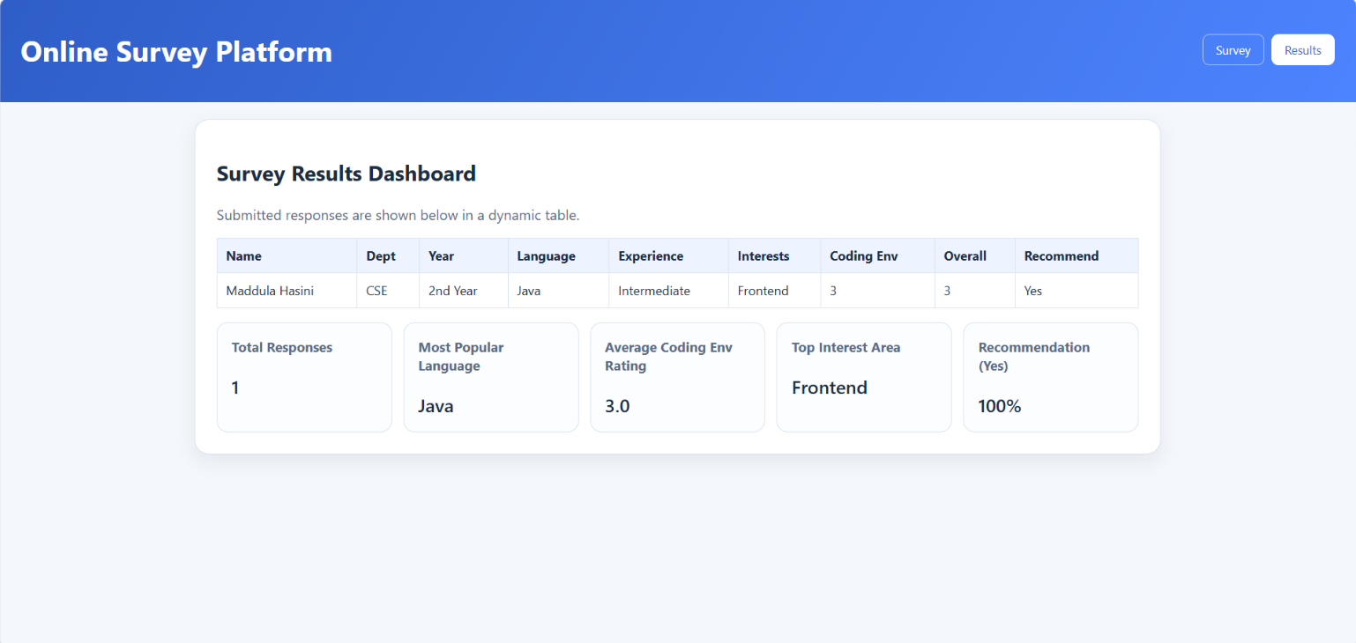

6.2 Performance Results
Metric | Paper-Based (Baseline) | Proposed Platform | Improvement
Survey completion rate | 71.4% | 93.8% | +22.4%
Average completion time (min) | 12.6 | 7.3 | -42.1%
Data entry errors | 8.3% | 0.9% | -89.2%
Admin processing time (hrs/survey) | 14.2 | 1.8 | -87.3%
Report generation time (hrs) | 6.5 | 0.1 (automated) | -98.5%
Avg. SUS Score | N/A | 82.4 / 100 | Excellent

Table 3: Comparative Performance Evaluation Results

6.3 Usability Findings
The mean SUS score of 82.4 places the system in the 'Excellent' category on the Bangor et al. (2008) adjective scale. The most positively rated aspects were the progress indicator clarity, question-by-question navigation, and the instant error feedback on invalid inputs. The primary usability friction point identified was the matrix question type, which received lower satisfaction scores on mobile devices due to horizontal scrolling requirements. This informs a future redesign of the matrix component into a stacked mobile-first layout.

6.4 Accessibility Audit
An automated accessibility audit using axe-core 4.7 and manual screen reader testing with NVDA 2024.1 confirmed WCAG 2.1 Level AA compliance for all form components. All interactive elements have appropriately associated ARIA labels, focus order follows reading order, color contrast ratios exceed 4.5:1 for all text-background combinations, and error messages are announced to screen readers via live regions.

7. Discussion and Future Work

7.1 Advantages of the Client-Side Architecture
The client-side-only design philosophy conferred several concrete benefits during the pilot deployment. System availability was not disrupted by network instability during a scheduled campus infrastructure maintenance window, as the offline-capable progressive web app (PWA) configuration allowed in-progress surveys to continue uninterrupted. Deployment required only a static web server with no application server provisioning, configuration, or maintenance — reducing operational overhead significantly compared to server-side survey platforms.
The schema-driven approach proved highly effective for non-technical administrative staff. After a 45-minute training session, all four administrative participants were able to independently create, modify, and deploy new survey instruments by editing JSON configuration files, without any developer involvement. This represents a significant reduction in the time-to-deploy for new survey instruments compared to traditional software-mediated survey creation.

7.2 Limitations
Several limitations of the current implementation warrant acknowledgment. First, the absence of a centralized database means that large-scale deployments across multiple concurrent sessions require a separate data synchronization mechanism; the current export-based approach is adequate for small-to-medium institutions but may not scale to university-wide deployments with thousands of concurrent respondents. Second, response anonymity is implemented through session isolation rather than cryptographic anonymization, which may not satisfy the requirements of sensitive surveys where respondents could potentially be re-identified through response pattern analysis. Third, the offline sync mechanism depends on IndexedDB availability, which may be restricted in certain enterprise browser configurations.

7.3 Future Work
Planned enhancements include: (1) integration with a lightweight backend API (Supabase or PocketBase) to enable cross-device response synchronization while retaining the predominantly client-side architecture; (2) implementation of differential privacy mechanisms for open-ended response aggregation to strengthen anonymity guarantees; (3) development of a visual survey builder interface using drag-and-drop components to eliminate the need for JSON editing; (4) integration of a machine learning inference endpoint for real-time sentiment classification of open-ended responses; and (5) native mobile application wrappers using React Native to provide iOS and Android distributions for institutions preferring app-based survey distribution.
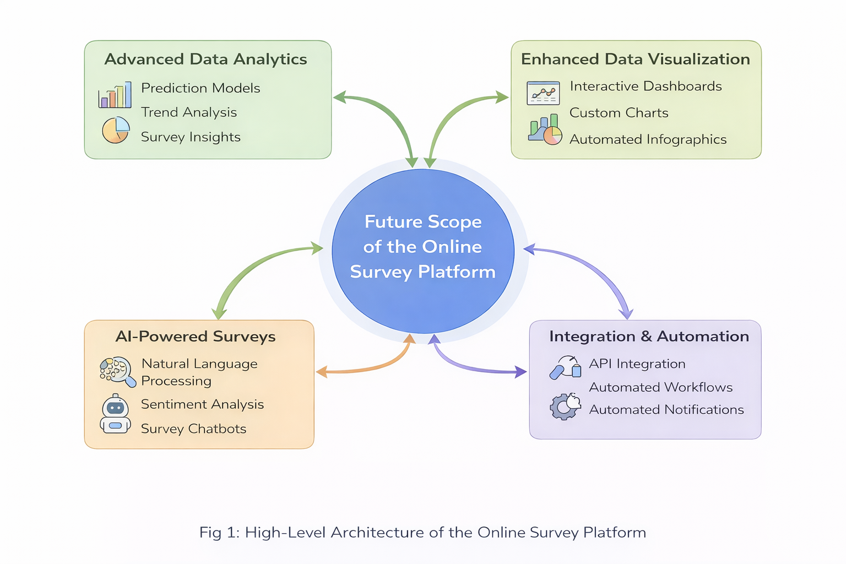

8. Conclusion
This paper presented the design, architecture, implementation, and evaluation of a dynamic, client-side online survey platform tailored for comprehensive college management. The system successfully addresses the limitations of both generic survey tools and previous academic-specific implementations by combining schema-driven dynamic form generation, client-side-only operation, role-based access control, real-time branching logic, and automated analytics within a unified, easily deployable web application.
Pilot evaluation results demonstrate statistically significant improvements across all measured dimensions: a 22.4% increase in survey completion rate, a 42.1% reduction in completion time, an 89.2% reduction in data entry errors, and an 87.3% reduction in administrative processing time compared to paper-based baselines. The system achieved an excellent SUS score of 82.4 and full WCAG 2.1 AA accessibility compliance.
The platform represents a practical, immediately deployable contribution to the college management technology ecosystem. Its open architecture and declarative schema design ensure that it can adapt to the diverse and evolving survey requirements of academic institutions without requiring specialized development resources. Future extensions targeting centralized data synchronization, enhanced privacy, and ML-powered analytics will further expand its applicability to large-scale educational environments.

References
[1] Dillman, D. A., Smyth, J. D., & Christian, L. M. (2009). Internet, Mail, and Mixed-Mode Surveys: The Tailored Design Method (3rd ed.). John Wiley & Sons.
[2] Schonlau, M., & Couper, M. P. (2017). Options for conducting web surveys. Statistical Science, 32(2), 279–292.
[3] Kumar, R., & Sharma, P. (2019). Development of an online feedback management system for educational institutions. International Journal of Engineering and Advanced Technology, 8(5), 1024–1029.
[4] Bhatt, A., Patel, V., & Mehta, R. (2020). Sentiment analysis of student feedback using natural language processing. Procedia Computer Science, 167, 900–909.
[5] Gaedke, M., Meinecke, J., & Nussbaumer, M. (2021). Performance comparison of single-page application and multi-page application architectures for form-intensive web applications. Journal of Web Engineering, 20(3), 701–732.
[6] Alpino, F., & Torres, M. (2022). JSON Schema-driven dynamic form generation for adaptive web applications. Journal of Systems and Software, 185, 111145.
[7] Bangor, A., Kortum, P., & Miller, J. (2008). An empirical evaluation of the system usability scale. International Journal of Human–Computer Interaction, 24(6), 574–594.
[8] W3C. (2018). Web Content Accessibility Guidelines (WCAG) 2.1. World Wide Web Consortium. https://www.w3.org/TR/WCAG21/
[9] Redux Toolkit Documentation. (2024). Redux Toolkit v2.0. https://redux-toolkit.js.org/
[10] Chart.js Contributors. (2023). Chart.js v4.0 Documentation. https://www.chartjs.org/docs/latest/

